**Department of Information Systems and Cyber Security University of Texas in San Antonio**



IS 3413: Telecom and Networking-001, Fall, 2022

Name: Daniel Cook  
UTSA ID: dhz799  
Email address: *danielwcook5@gmail.com*

Lab Assignment: Lab: M10 – Internet tools  
Date Due: 11/5/2022  
Date Submitted: 11/5/2022

1a. Provide a screenshot of the Internet Exchange Map showing the 2 IXPs located nearest to San Antonio. Write the address for each of these IXPs.

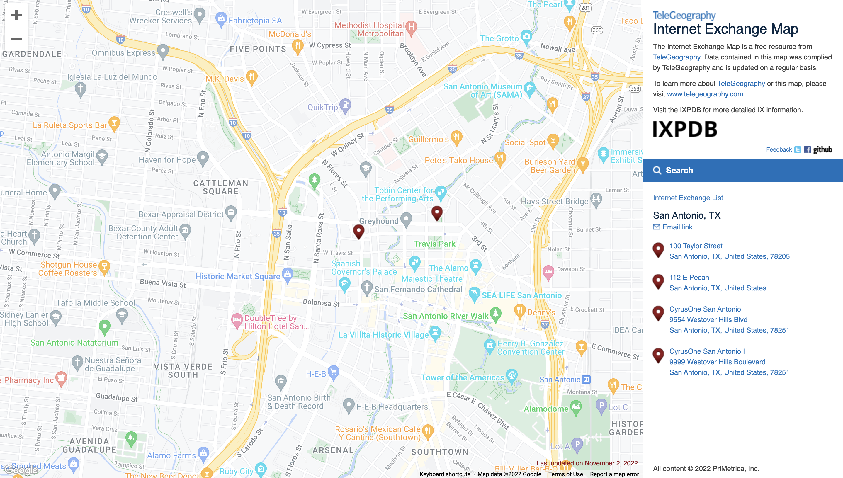

100 Taylors Street, San Antonio TX, U.S. 78205

112 E Pecan, San Antonio TX, U.S.

1b. What country (other than the United States) do you think has a high concentration of IXPs relative to its geographic boundaries? Include a screenshot/snippet.

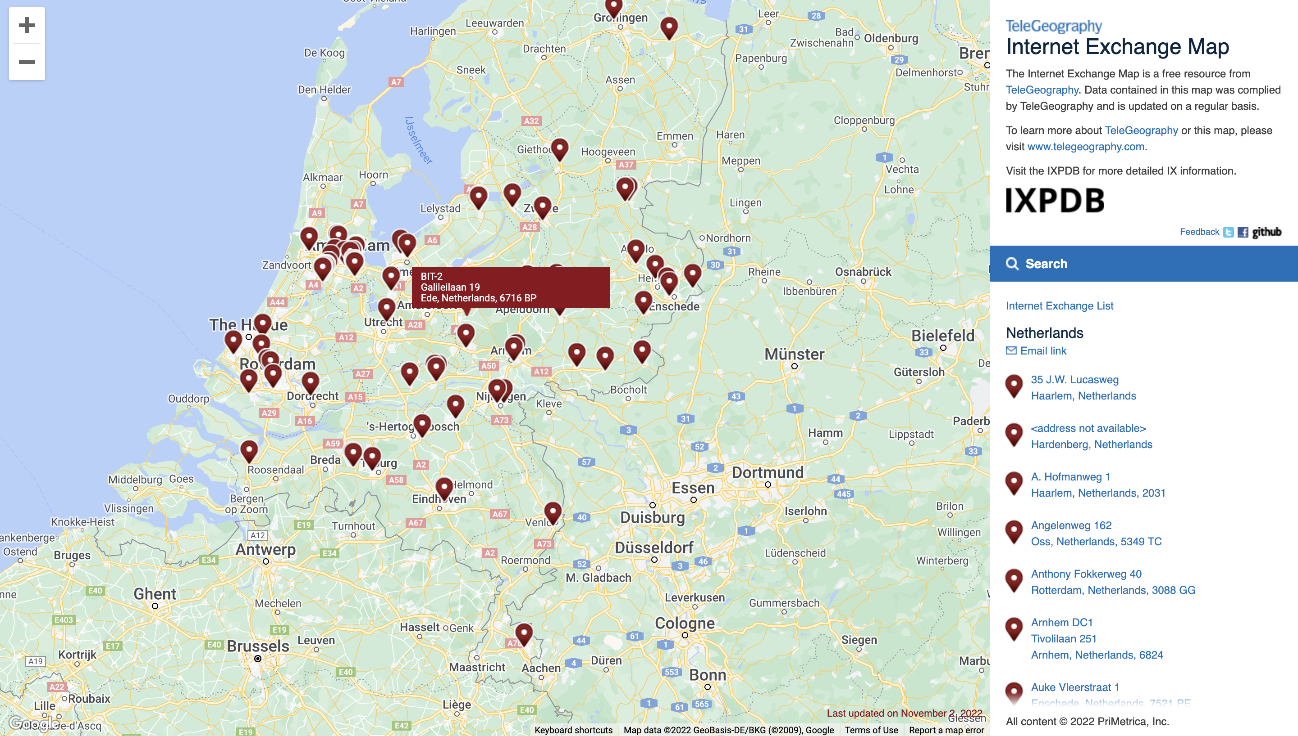

I would say the Netherlands other than the U.S. has a high concentration of IXPs.

2a. What is the Name listed in the Registrar Info for amazon.com? When was this domain registered and when is the registration scheduled to expire? What is the IP address of the first Name Server listed?

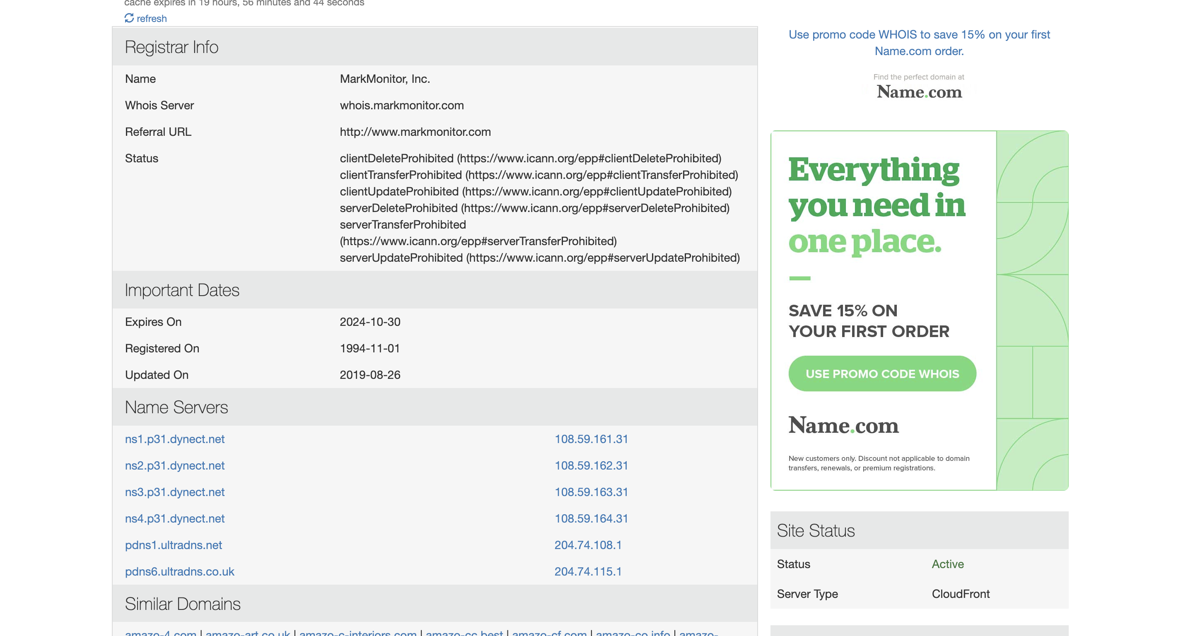

Mark Monitor, Inc., the domain was registered on 1994-11-01 and expires on 2024-10-30. The IP address on the first name server is 108.59.161.31

2b. What domain name did you test for registration availability? Was it available as a .com? If not, to whom was it registered (Name in Registrar Info)?

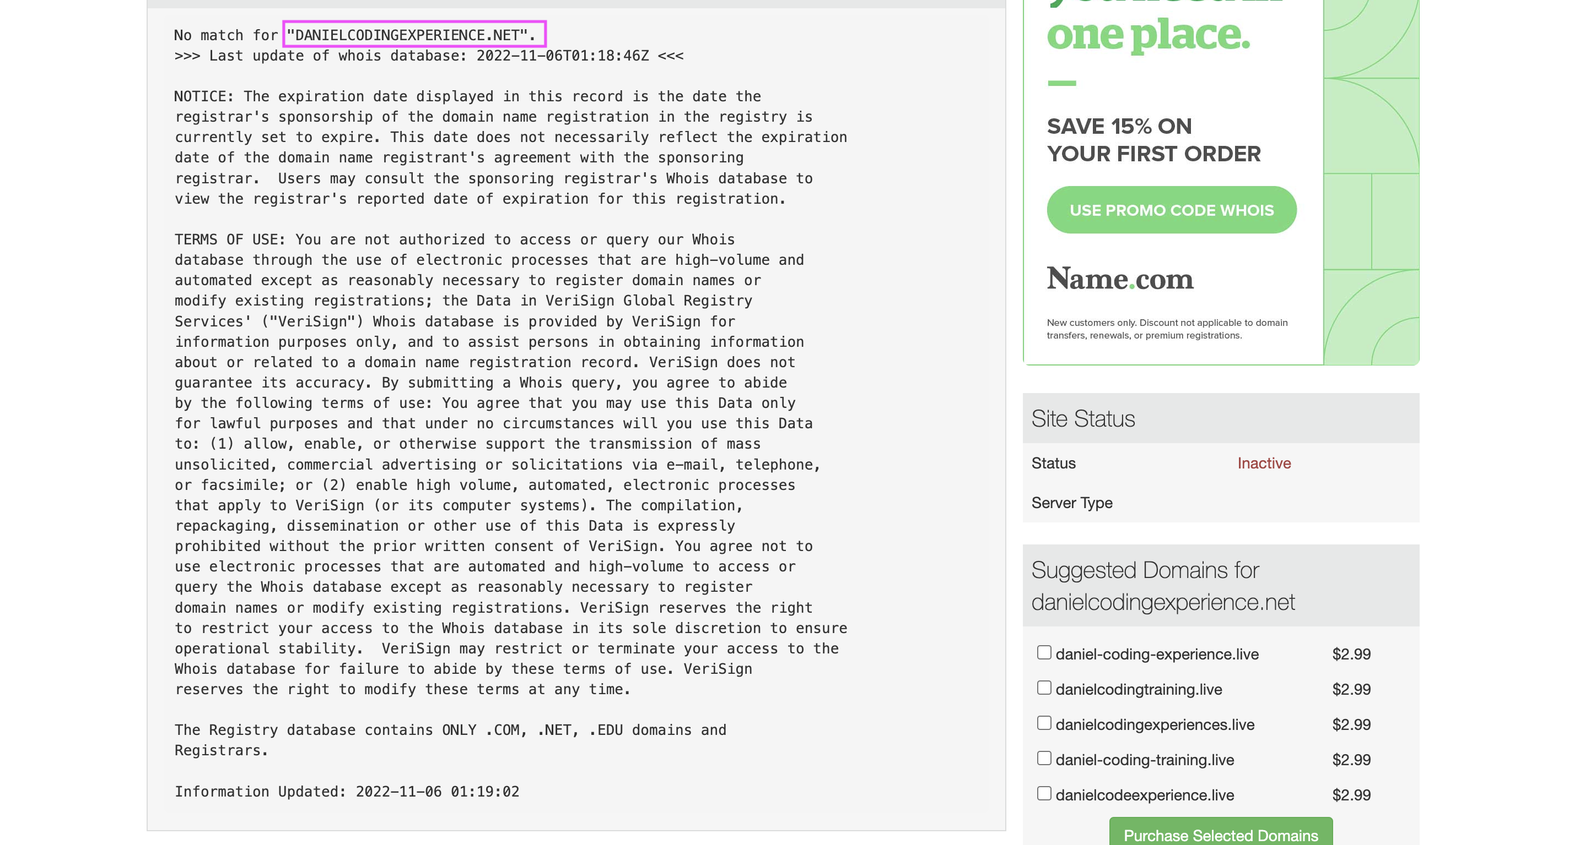

The domain that I tested is danielcodingexperience.net, and it is not active.

3a. What IP addresses were provided for www.espn.com(provide a screenshot/snippet)?

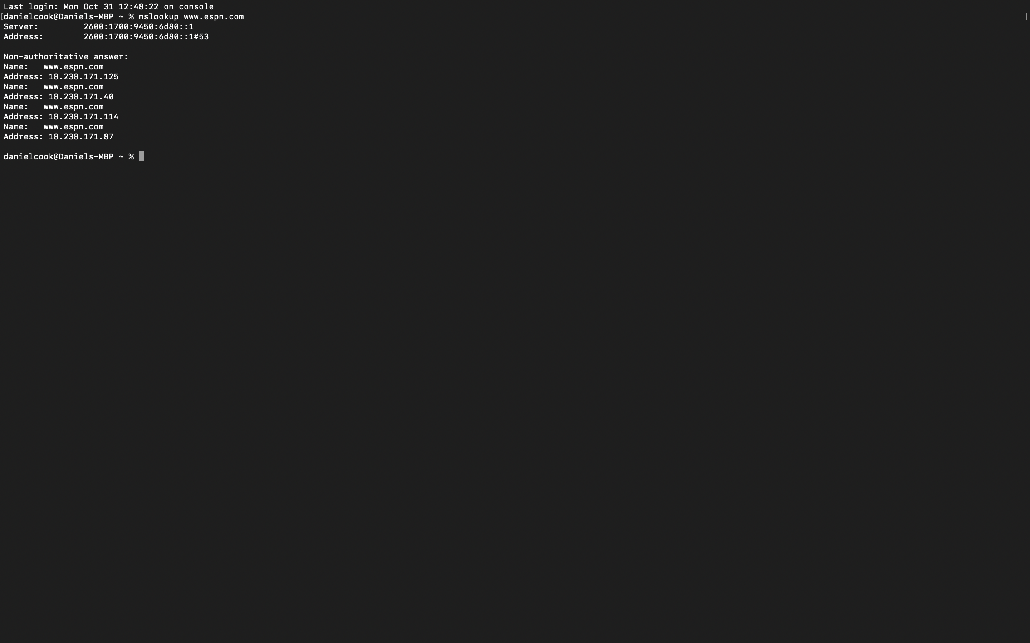

There are 4 addresses- 18.238.171.125, 18.238.171.40, 18.238.171.114, 18.238.171.87

3b. What IP addresses were provided for www.utsa.edu (provide a screenshot/snippet)?

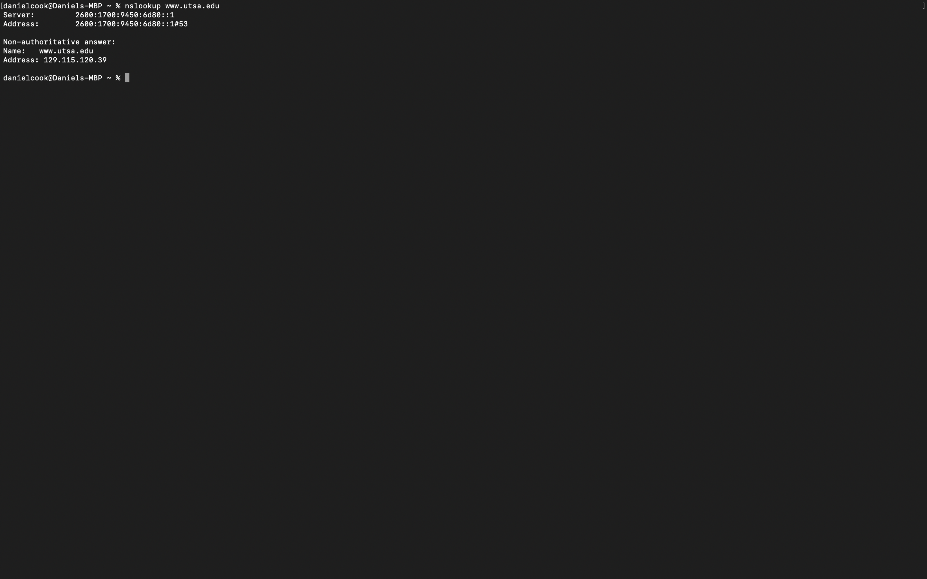

There is 1 address- 129.115.120.39